Moses:
Awe & Wonder, Law & Thunder
6:45 Term 3 2022
Front Cover:
Moses and the Burning Bush
Marc Chagall, 1966
The Jewish Museum, New York
Contents:
1. Moses
by Michelangelo, 1515.
Church of San Pietro in Vincoli, Rome.
2. Moses Brought Before Pharaoh's Daughter
By William Hogarth, 1746.
The Foundling hospital, London.
3. The Trials of Moses & the Temptations of Christ
By Sandro Botticelli, 1482.
Sistine Chapel, Vatican City.
5. Landscape with Moses and the Burning Bush
By Domenichino, 1616.
The MET, New York.
6. Moses before the Burning Bush
Domenico Fetti, 1614
Kunsthistorisches Museum, Vienna
7. The Fifth Plague of Egypt
J.M.W Turner, 1800
Indianapolis Museum of Art, Indianapolis
8. And there was a cry in Egypt
Arthur Hacker, 1897
Private collection
9. Crossing of the Red Sea
By Cosimo Rosselli, 1482.
Sistine Chapel, Vatican City.
10. The Adoration of the Golden
by Nicolas Poussin,1634
National Gallery, London
10. Victory O Lord!
John Everett Millais, 1871
Manchester Art Gallery, Manchester
11. The Brazen Serpent
Anthony van Dyck, 1620
Museo del Prado, Madrid
12. The Death of Moses
Alexandre Cabanel, 1850
Fabre Museum, Montpellier
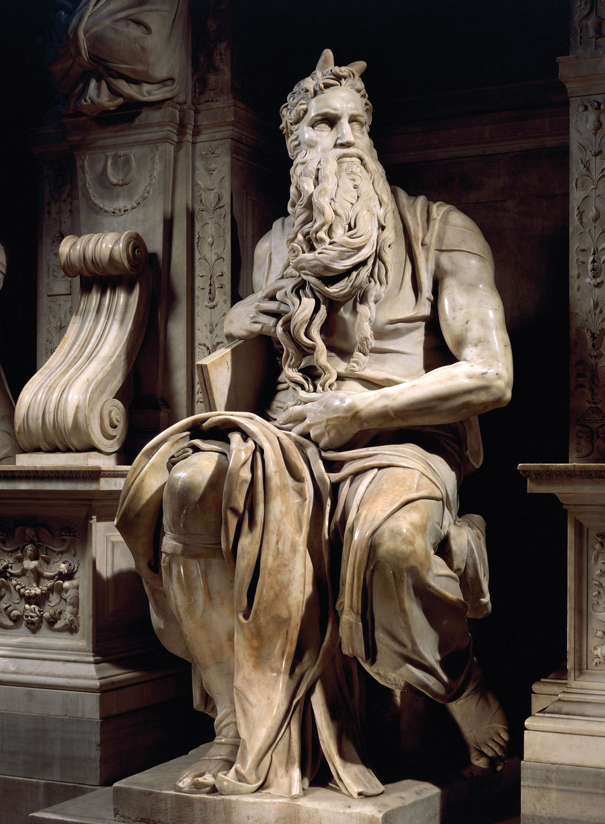
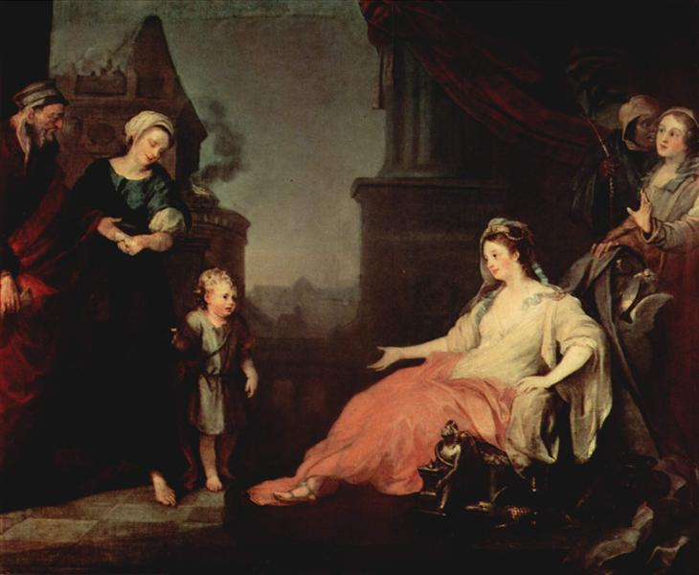
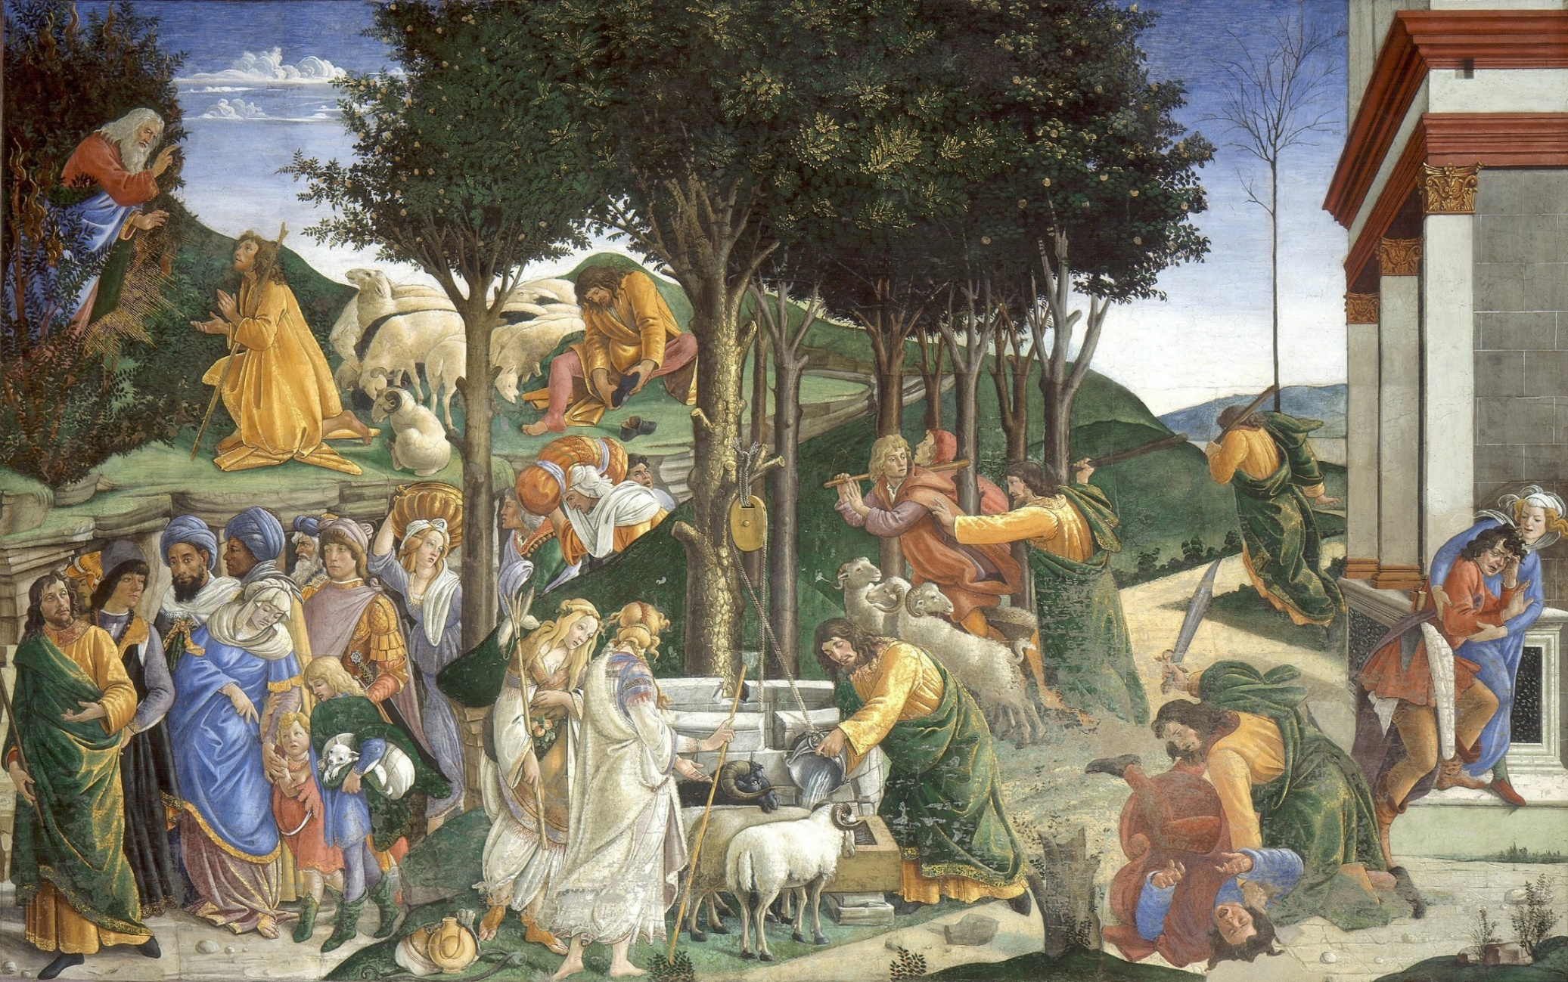
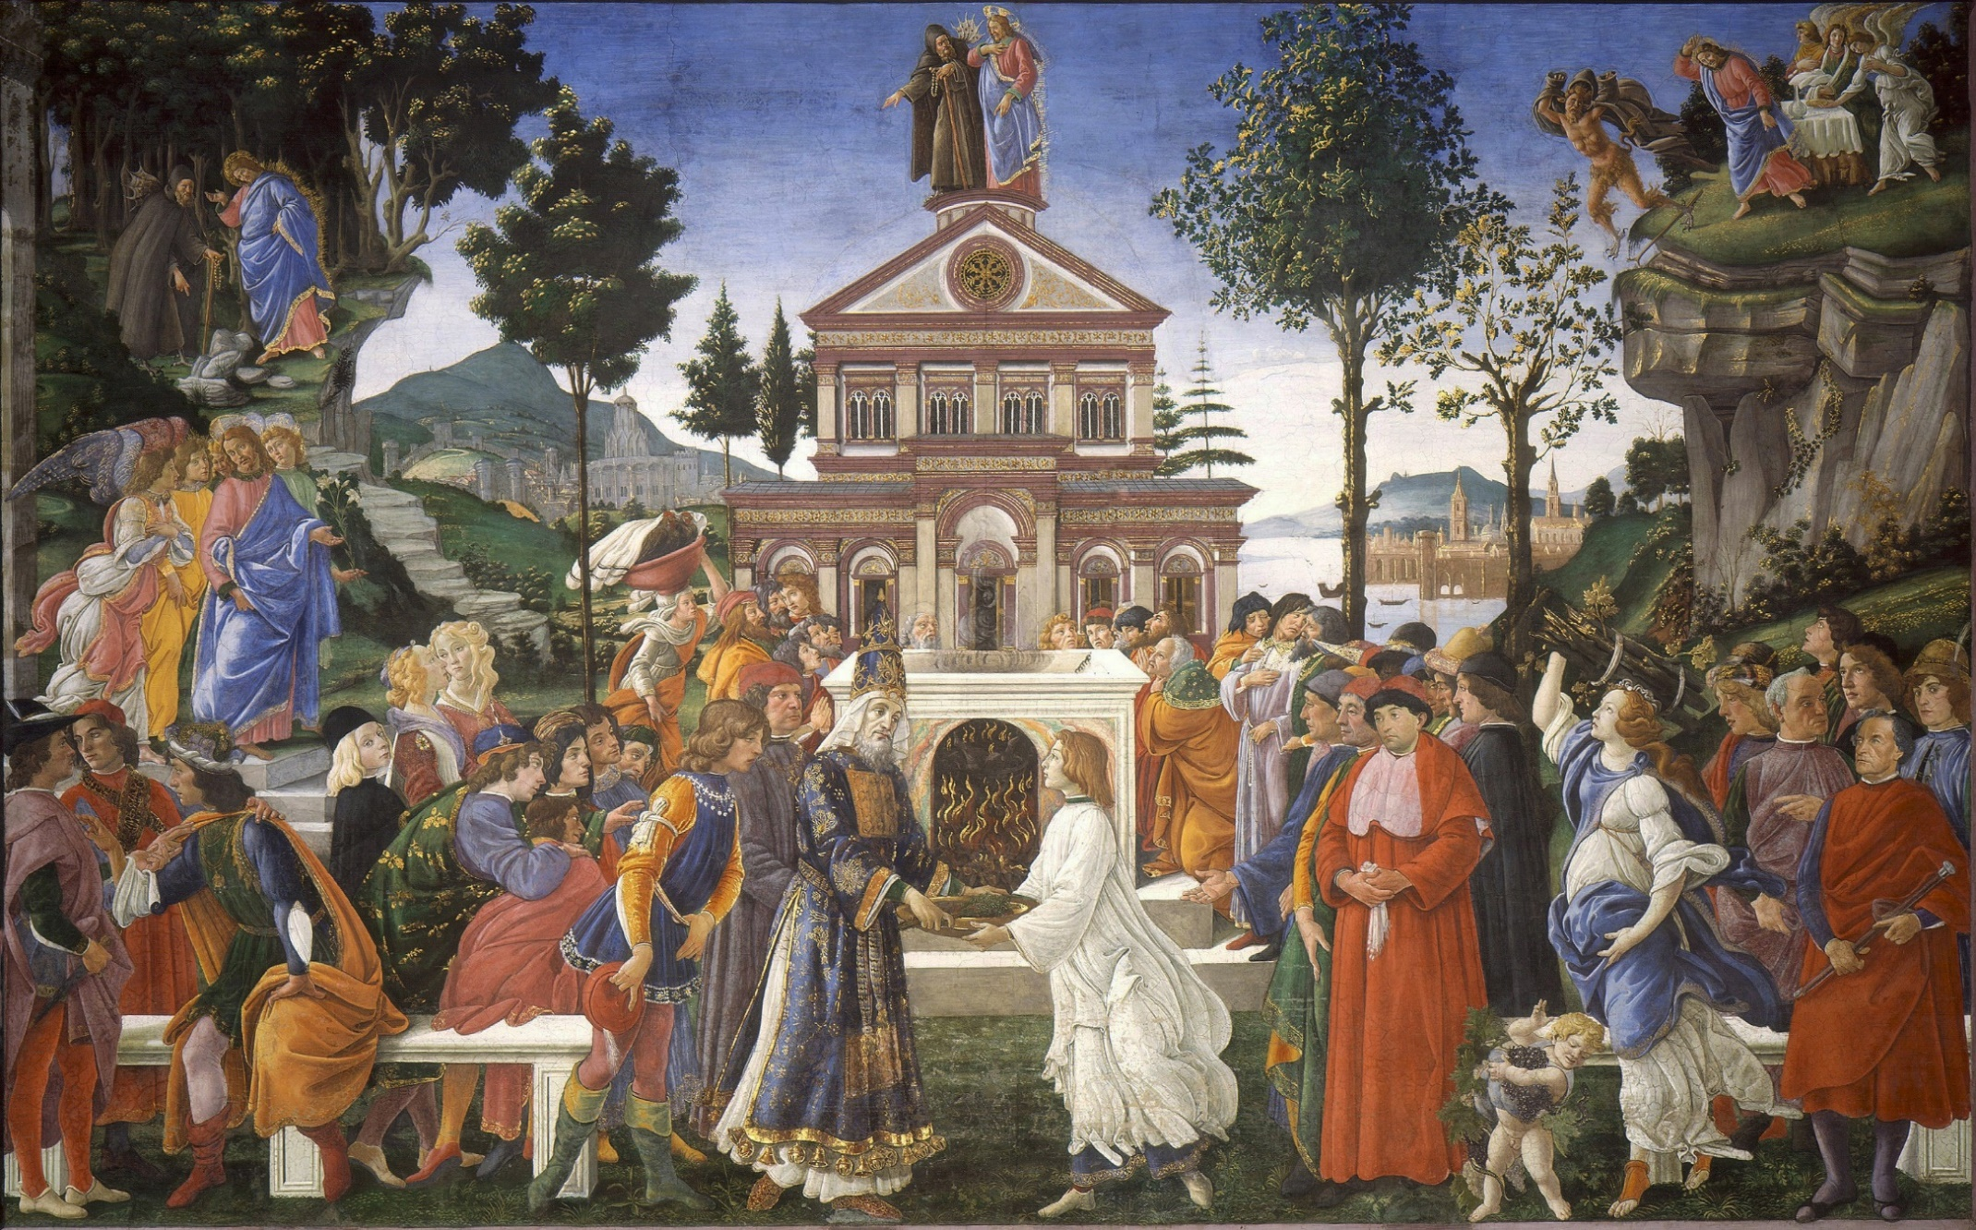
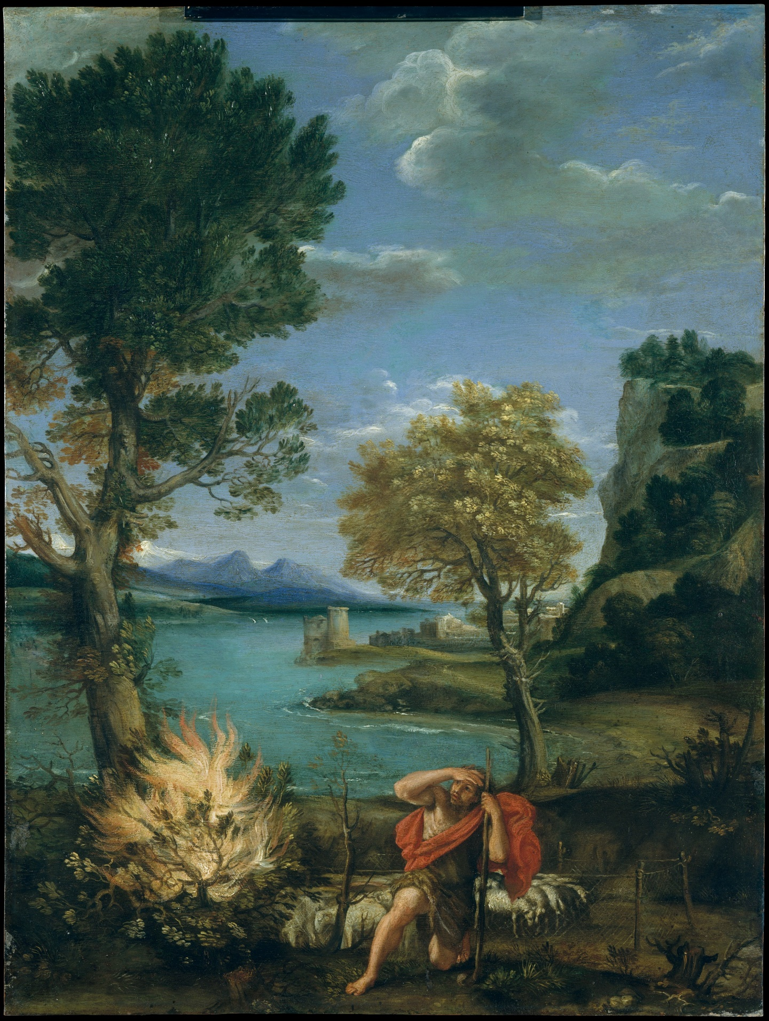

The Burning Bush
When Moses, musing in the desert, found
The thorn bush spiking up from the hot ground,
And saw the branches on a sudden bear
The crackling yellow barberries of fire,

He searched his learning and imagination
For any logical, neat explanation,
And turned to go, but turned again and stayed
And faced the fire and knew it for his God.

I too have seen the briar alight like coal,
The love that burns, the flesh that’s ever whole,
And many times have turned and left it there,
Saying: “It’s prophecy–but metaphor.”

But stinging tongues like John the Baptist shout:
“That this is metaphor is no way out.
It’s dogma too, or you make God a liar;
The bush is still a bush, and fire is a fire.”

Norman Nicholson
The Earth is the Lord’s: Poems of the Spirit (1965)

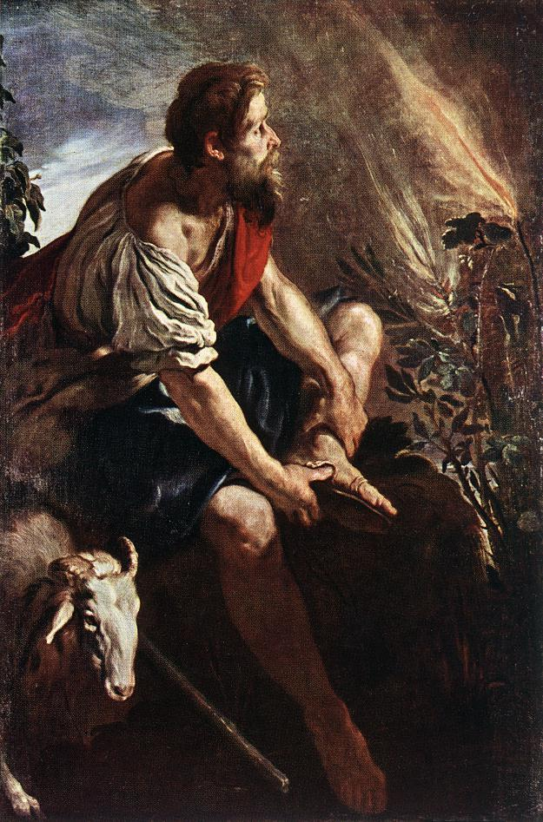
The Bright Field
I have seen the sun break through
to illuminate a small field
for a while, and gone my way
and forgotten it. But that was the
pearl of great price, the one field that had
treasure in it. I realise now
that I must give all that I have
to possess it. Life is not hurrying

on to a receding future, nor hankering after
an imagined past. It is the turning
aside like Moses to the miracle
of the lit bush, to a brightness
that seemed as transitory as your youth
once, but is the eternity that awaits you.

R.S. Thomas
Laboratories of the Spirit (1975)

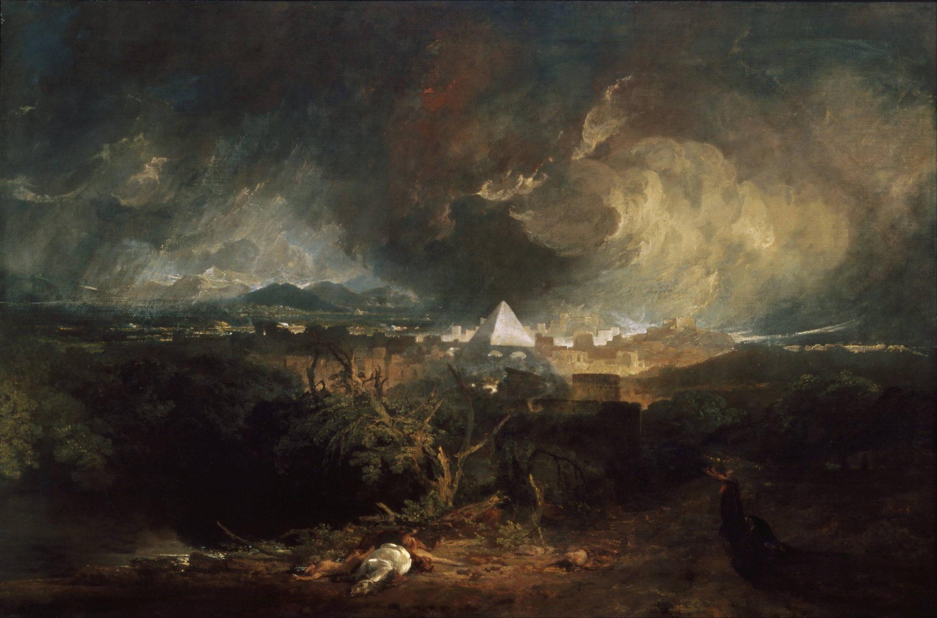
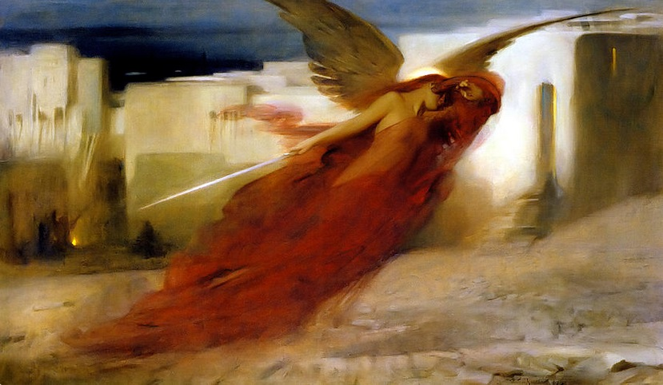
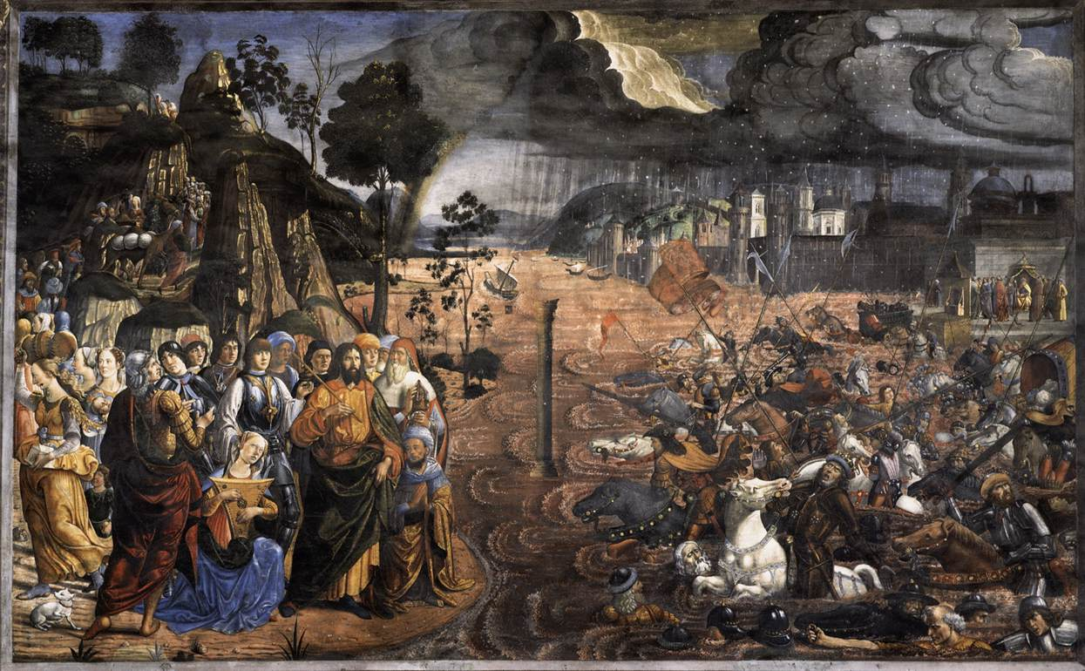
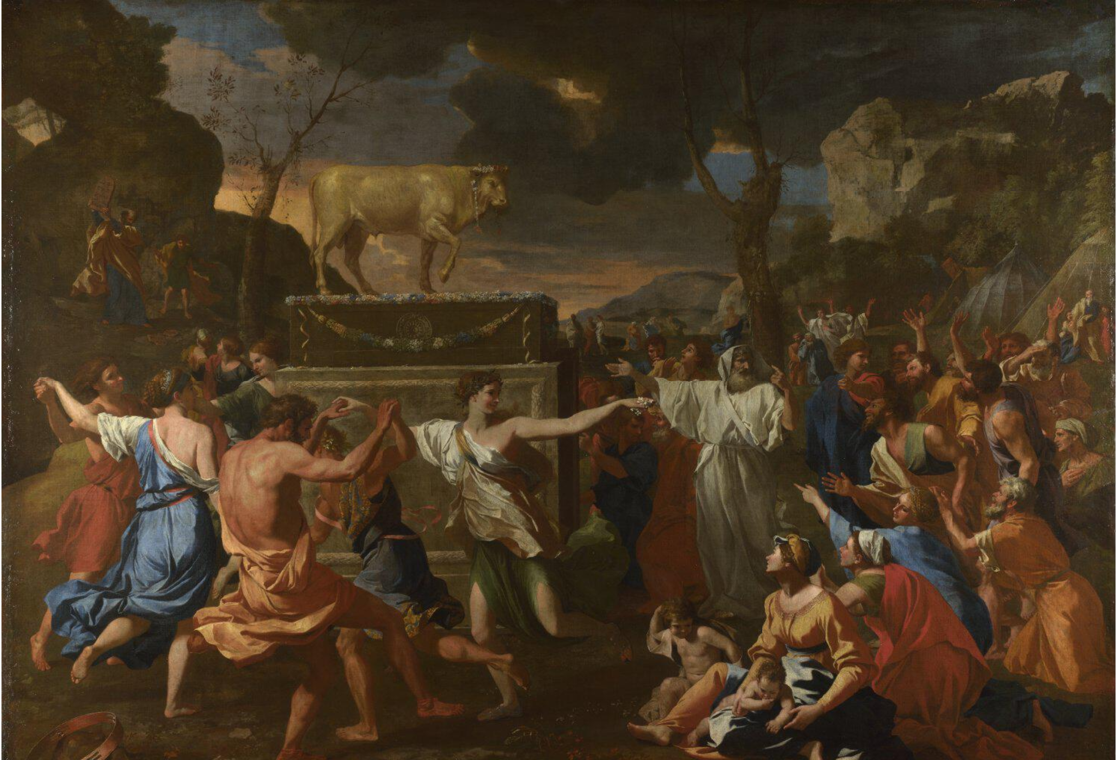
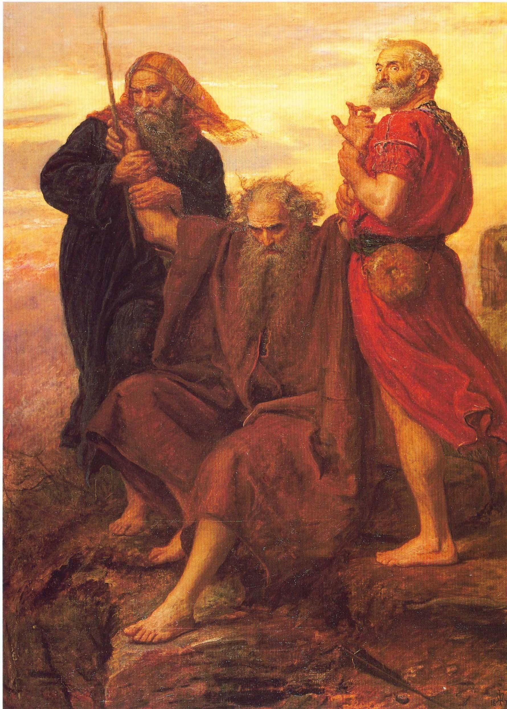
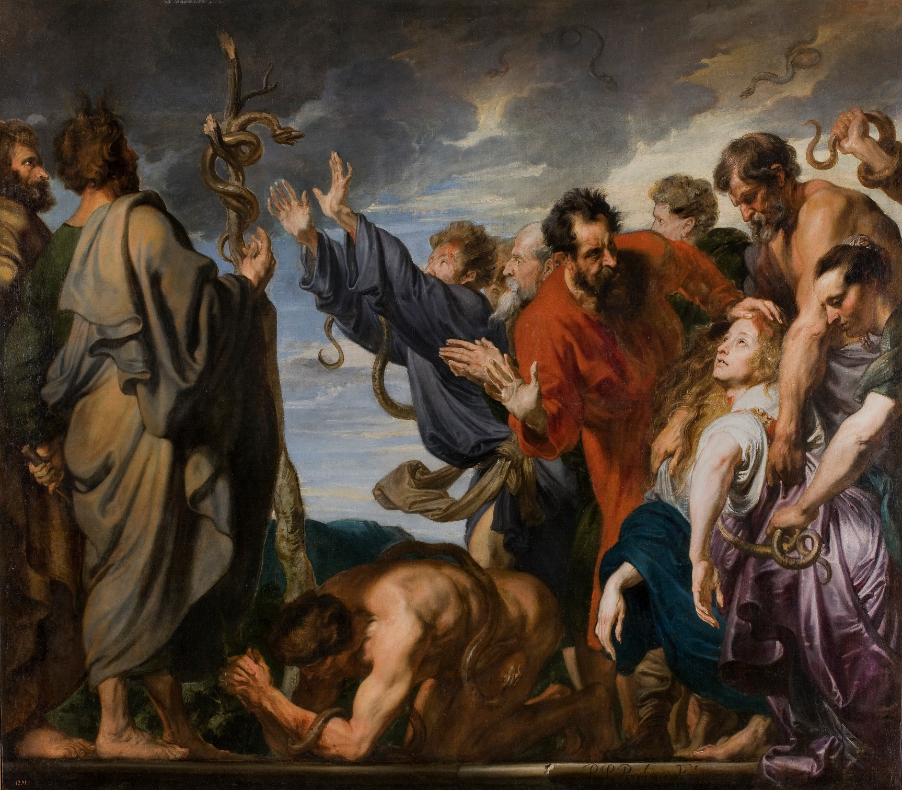

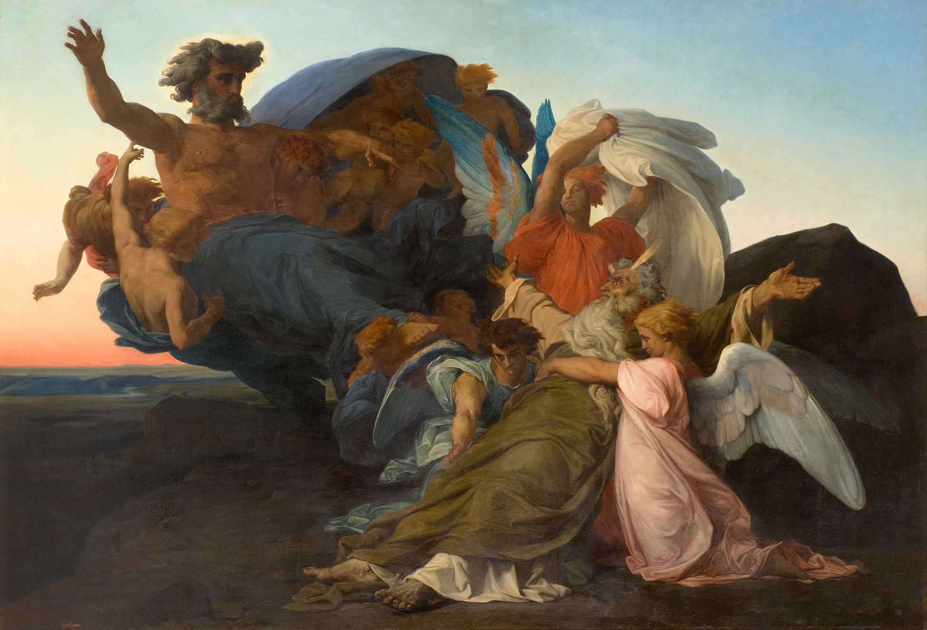
Back Cover:
Moses and Pharoah's Daughter
Peter Koenig, 1997
Private Collection

